

.

Monthly Report
July 2026
AB Bank Liberia

Contents
1. Executive Summary 2
1.1. Key Highlights: 2
1.1.1. Incident Volume & Trends: 2
1.1.2. Detection & Response Performance: 2
1.2. Incident Trends & Analysis: 4
1.3. High-Severity Incidents & Escalations: 5
2. July Alerts & Incidents Overview 5
2.1. Overall Volume 5
2.2. Incidents Processing 5
2.3. Mean Time to Detect (MTTD) 6
3. Incidents Highlights 7
3.1. Top 10 incidents by type 7
3.2. Analysis of Key Incident Trends 7
3.3. High Severity 13
4. Cybersecurity Trends and Threats – Liberia 13
4.1. Key Threats, Incidents & Legal Development 13
4.2. Regional spillover and Infrastructure Risks 14
4.3. Government and Industry Response 15
5. Recommendations 17
6. Conclusion 17

Executive Summary
This security report provides an in-depth analysis of security incidents, alerts, and operational activities managed by TeKnowledge for AB Bank Liberia during the reporting period. The findings highlight key security trends, detection and response performance, and proactive measures taken to enhance the organization’s security posture.

Key Highlights:

Incident Volume & Trends:
A total of 1101 security incidents were processed in Microsoft Sentinel during July 2026, across the monitored AB Bank Liberia environment.
During the recent monitoring period, the most prevalent security events included Source Stopped Sending Data: Security Events, Source Stopped Sending Data: FortiGate, Source Stopped Sending Data: Syslog, AD Account Lockout, Critical User Events. These categories show that authentication hygiene, time-source reliability, endpoint/agent health, and firewall authentication monitoring remained the dominant operational security themes for the month.

Detection & Response Performance:
Mean Time to Detect (MTTD): The mean time to detect for July was 2 hours and 19 minutes. This continues to show effective real-time monitoring and prompt analyst visibility across Microsoft Sentinel.
Additionally, the breakdown of MTTD by severity is as follows:
Medium Severity: 25 minutes and 21 seconds
Informational Alerts: 15 hours 48 minutes and 36 seconds

Average Time to First Response: Across all July incidents, the average first response time was 9 minutes and 43 seconds.
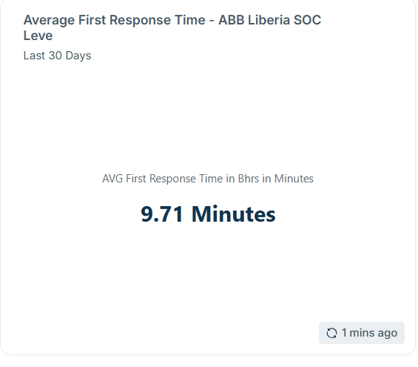

Average Mean Time to Resolution (MTTR): The average Mean Time to Resolution (MTTR) for this reporting period was 3 minutes 0 seconds.
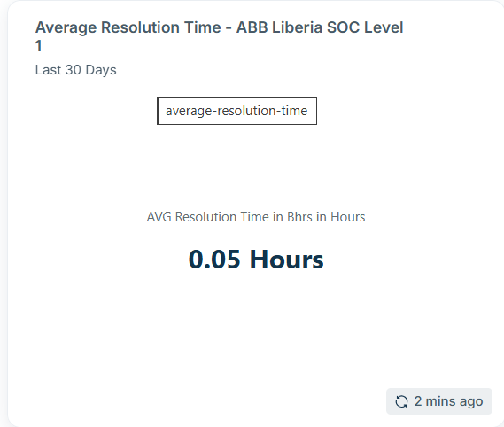

Availability Rate: No major production service outage was recorded during the reporting period, and client-facing service continuity remained stable. However, security monitoring availability was temporarily affected when the Sentinel subscription entered a suspended state, resulting in a temporary loss of log ingestion and telemetry visibility.
While this did not represent a client service outage, it reduced SOC visibility during the affected window. Going forward, subscription health, connector status, and log ingestion monitoring should be strengthened to ensure continuous security visibility alongside service availability.

Incident Trends & Analysis:
During July 2026, the Security Operations Center (SOC) recorded a total of 1101 security-related incidents, an increase from the previous month's 812 incidents. The month-over-month increase of 289 incidents (approximately 26.2%) were mainly due to visibility blind spots due to the Azure subscription entering a suspended state again and points to lower operational noise, while the persistence of account lockouts and time synchronization failures shows that authentication and infrastructure health remain areas requiring continuous attention.
The most frequent incidents observed were Source Stopped Sending Data: Security Events (253), Source Stopped Sending Data: FortiGate (203), Source Stopped Sending Data: Syslog (174), AD Account Lockout (136), Critical User Events (98). Most incidents were medium severity, with no High severity alert recorded under Classification results were dominated by Benign Positive outcomes, with a small number of True Positive, False Positive, Undetermined, and active/unclassified records requiring continued follow-up.
Overall, July reflected continued incident volume reduction compared with May, but the environment remained active. Account lockout activity remained the main driver of workload, Windows time synchronization failures persisted as a recurring infrastructure-health concern, and after-hours RDP activity increased materially. SOC response remained fast, while resolution timing indicates that closure discipline for long-running tickets should remain a focus area.
The most frequent alerts were related to:
- Source Stopped Sending Data: Security Events (253 Events)
- Source Stopped Sending Data: FortiGate (203 Events)
- Source Stopped Sending Data: Syslog (174 Events)
- AD Account Lockout (136 Events)
- Critical User Events (98 Events)
- Incidents Summary Alert (58 Events)
- Heartbeat Missing (54 Events)
- Remote Desktop Access After Working Hours (40 Events)
- Account Lockout: Admin Users (31 Events)
- Windows: Time Synchronization Failure (18 Events)
All incident categories were reviewed and handled according to SOC triage procedures, with containment, validation, or escalation performed where necessary.

High-Severity Incidents & Escalations:
During the reporting period, there was no High Severity incident recorded.

July Alerts & Incidents Overview

Overall Volume
In the month of July, a total of 812 incidents were handled on MS Sentinel. This volume includes both incidents manually processed by the security team and incidents addressed through pre-configured automation and standard triage workflows.
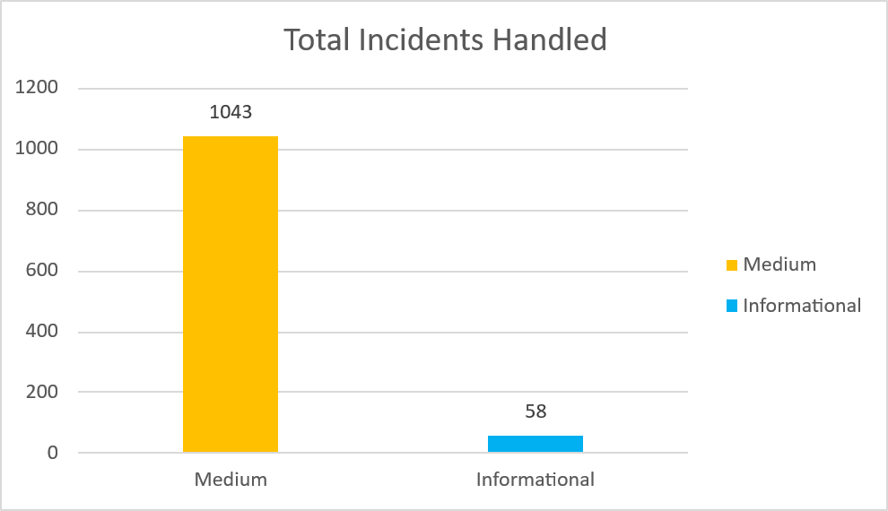

Incidents Processing
During the reporting period, TeKnowledge successfully monitored, detected, and responded to 1101 security incidents within the AB Bank Liberia environment. The SOC team processed all incidents, ensuring a comprehensive approach to threat detection and response.
The final classification breakdown included 18 true positives, 1001 benign-positives, 71 Undetermined.

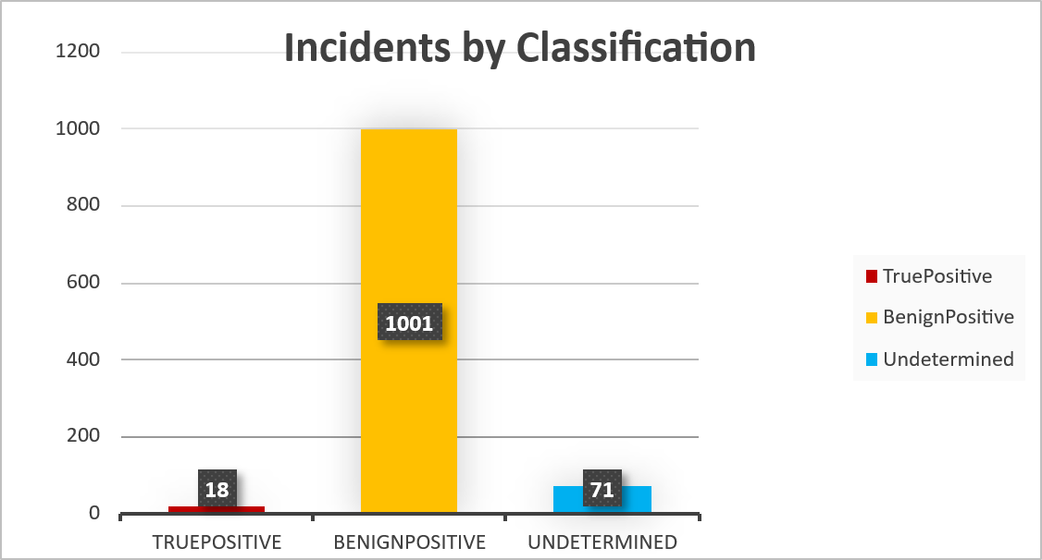
This outcome reflects a structured alert review process that emphasizes accurate categorization and effective incident validation, ensuring that remediation efforts remain focused on genuine security threats while minimizing operational noise.

Mean Time to Detect (MTTD)
The average Mean Time to Detect (MTTD) for this reporting period was recorded at 2 hours and 19 minutes. This spike was caused by the SOC being unable to acknowledge or modify alerts (Source Stopped Sending Data) during the period the Azure Subscription entered a suspended state.
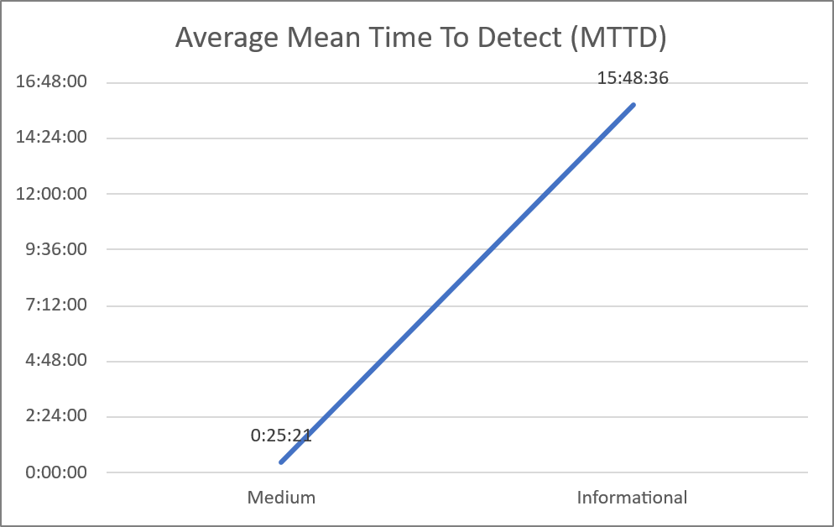

Incidents Highlights

Top 10 incidents by type
During the reporting period, TeKnowledge monitored and categorized security incidents, identifying the most prevalent issues within your environment. Below is a breakdown of the top incident types detected:

Incident Title | Count of Title
Source Stopped Sending Data: Security Events | 253
Source Stopped Sending Data: FortiGate | 203
Source Stopped Sending Data: Syslog | 174
AD Account Lockout | 136
Critical User Events | 98
Incidents Summary Alert | 58
Heartbeat Missing | 54
Remote Desktop Access After Working Hours | 40
Account Lockout: Admin Users | 31
Windows: Time Synchronization Failure | 18
Grand Total | 1065

Analysis of Key Incident Trends
During this reporting period, TeKnowledge identified and categorized multiple security incidents within the AB Bank Liberia’s environment. The breakdown below highlights key trends, notable threat patterns, and actionable recommendations to improve detection and response capabilities.
- Source Stopped Sending Data: Security Events (253 Incidents)
Description: This alert was triggered because no data was observed in the SecurityEvent table within the configured monitoring window. The disruption occurred because the related subscription was suspended, which temporarily stopped Security Event logs from being ingested into Sentinel.
The absence of Security Event logs can create visibility gaps for key activities such as user logons, account lockouts, privilege use, policy changes, and other Windows security events. Although the trigger was caused by a subscription issue and not malicious activity, it still affected monitoring coverage during the period.
Recommendations:
  - Configure alerts for subscription suspension, connector health, and ingestion failures.
  - Regularly review billing, licensing, and subscription status to prevent unexpected monitoring interruptions.
  - Maintain a log-source health dashboard for critical tables such as SecurityEvent, Syslog, SigninLogs, and Heartbeat.

- Source Stopped Sending Data: FortiGate (203 Incidents)
Description: This alert triggered because FortiGate logs stopped being received in Sentinel within the configured monitoring window. This indicates a temporary loss of firewall telemetry, which can create visibility gaps for important events such as VPN activity, administrator logins, blocked traffic, policy violations, intrusion attempts, and network threat detections.
While this may be caused by log forwarding issues, connector failure, network interruption, or device-side logging problems, loss of FortiGate data reduces the SOC’s ability to monitor perimeter and internal firewall activity effectively.
Recommendations:
- Validate FortiGate log forwarding configuration and confirm that Syslog/CEF logs are actively reaching the Sentinel collector.
- Configure proactive health monitoring for FortiGate connectors, log collectors, and ingestion pipelines to detect telemetry loss early.
- Implement redundancy for critical firewall log forwarding, such as secondary collectors or failover paths, to reduce monitoring blind spots

- Source Stopped Sending Data: Syslog (174 Incidents)
Description: This alert triggered because Syslog data stopped being received in Sentinel within the configured monitoring window. Syslog is commonly used to collect logs from network devices, Linux servers, firewalls, switches, routers, and other infrastructure components.
A disruption in Syslog ingestion can create monitoring blind spots and may prevent the SOC from detecting authentication failures, configuration changes, network anomalies, device health issues, and potential security events from non-Windows systems. The issue may be caused by collector downtime, network connectivity problems, device-side logging failure, or Syslog service misconfiguration.
Recommendations:
  - Validate that all critical Syslog sources are actively forwarding logs to the correct collector and that required ports, such as UDP/TCP 514, are open and reachable.
  - Implement proactive health monitoring for Syslog collectors and alert when expected log volume drops or stops completely.
  - Configure redundant Syslog collectors or failover forwarding paths for critical devices to reduce visibility gaps during collector or network outages.

- AD Account Lockout (136 Incidents)
Description: Account lockout events were observed across the Active Directory environment during the reporting period, the highest lockout activity was associated with accounts such as mgblinwon, Canice.Morris, tbuxton, vezele.gbogie, rvankpanah, and eblackie. The most affected source systems included S-ABL-PDC-SD, S-ABL-PDC-SMS, S-ABL-PDC-REP_2, S-ABL-PDC-APP, and S-ABL-PDC-PR1.
Most events were recorded through S-ABL-GTB-RODC, followed by S-ABL-KB-RODC and S-ABL-PDCDC1, indicating that authentication failures were spread across multiple domain controllers and branch authentication points. The pattern suggests likely stale or cached credentials, mapped drives, scheduled tasks, persistent sessions, or services attempting authentication with outdated credentials. No confirmed malicious activity was identified from the logs reviewed.
Recommendations:
- Review services, scheduled tasks, scripts, mapped drives, and application pools using affected accounts.
- Clear cached credentials from Windows Credential Manager and endpoint applications where applicable.
- Implement managed service accounts or group managed service accounts where supported.

- Critical User Events (98 Incidents)
Description: The activity was mainly concentrated around account lockouts, privileged/local group membership enumeration, password reset attempts, account changes, and account unlocks.
The most observed event was Event ID 4740 — User Account Locked Out, with 72 occurrences. The highest recurring affected users were cmorris with 40 lockout events, rvankpanah with 20 lockout events These events were recorded mainly across domain controllers including S-ABL-GTB-RODC, S-ABL-KB-RODC, and S-ABL-PDCDC1.
Overall, the activity appears largely consistent with credential issues, administrative account handling, and possible system-driven enumeration, with no direct evidence of compromise from the provided data. However, because the events involve critical or privileged accounts, they should remain under enhanced monitoring.
Recommendations:
  - Enforce MFA and strong conditional access controls for privileged and critical users.
  - Review privileged group memberships and remove unnecessary elevated access.
  - Maintain tighter correlation between critical-user events, source hosts, and account-change activity.

- Heartbeat Missing (54 Incidents)
Description: Endpoints and monitoring agents typically send heartbeat messages at defined intervals to the central monitoring system or SIEM. Failure to receive a heartbeat can result from:
- Device being powered off, rebooted, or disconnected.
- Network issues preventing communication.
- Agent crashes, misconfiguration, or service stoppage.
- Potential malicious activity disabling telemetry to avoid detection.
The alert triggers when a heartbeat is not received within a configured window, signaling possible endpoint unavailability or telemetry loss.
Recommendations:
- Automate agent health checks and restart agents where safe and appropriate.
- Investigate repeated endpoint/network communication failures, especially for critical assets.
- Maintain redundant log collection paths where feasible to avoid visibility gaps.

- Remote Desktop Access After Working Hours (24 Incidents)
Description: Multiple Remote Desktop Protocol (RDP) access events were observed outside standard working periods, including evenings and weekends, from both internal and private IP addresses.
The activity involved several domain accounts, including eblackie, rvankpanah, swamah, tbuxton, cmorris, mgblinwon, nyriah, mbarrow, vezele.gbogie, and the service account SRVACCNPM. The highest activity was associated with eblackie, with repeated connections from 172.18.1.49 and 192.168.99.85.
Recommendations:
- Enforce multi-factor authentication (MFA) for all RDP access.
- Restrict RDP access to approved management hosts, VPN ranges, or jump servers.
- Implement session timeout and disconnected-session cleanup policies.

- Account Lockout: Admin Users (39 Incidents)
Description: Events flagged under this category involved repeated account lockout activities for the user cmorris. A total of 42 lockout events were observed during the reporting period, primarily linked to the assets S-ABL-PDC-CMAPP and S-ABL-PDC-APP.
The repeated lockouts suggest that incorrect or stale credentials June be stored on one or more systems, services, scheduled tasks, mapped drives, or active sessions.
Recommendations:
    - Enforce MFA and strong password hygiene for all privileged accounts.
    - Investigate the source system and process responsible for each repeated admin lockout.
    - Alert on abnormal admin login behavior, privilege escalation, and repeated failures outside approved maintenance windows

- Windows: Time Synchronization Failure (19 Incidents)
Description: During the reporting period, 122 Windows Time Synchronization Failure events were recorded across the environment. The events indicate that affected systems were unable to synchronize with the configured time source, with sample logs showing the NTP peer as unreachable.
However, the volume of events indicates a temporary disruption to time synchronization services across multiple systems. Accurate system time is critical for authentication, event correlation, log integrity, and incident investigation.
Recommendations:
- Configure all domain-joined systems to synchronize from the correct domain time source, typically the PDC emulator.
- Ensure UDP/123 is permitted between clients, servers, and their time sources.
- Review recurring affected endpoints for Windows Time service failure, DNS resolution issues, or blocked NTP traffic

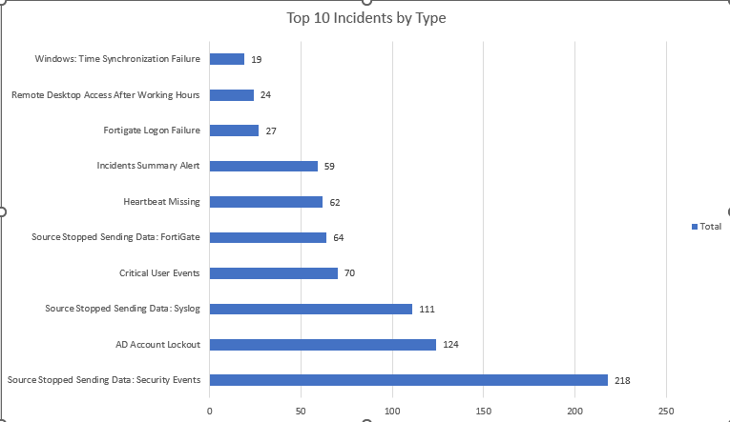

High Severity
During the reporting period, No High severity incident was recorded.

Cybersecurity Trends and Threats – Liberia
Executive overview. In August 2026, Liberia’s cybersecurity threat environment was shaped by increasingly sophisticated online scams, AI-enabled fraud pressure across West Africa, privacy and confidentiality failures involving financial data, and the rapid expansion of the country’s digital and regulatory infrastructure. The most immediate citizen-facing threat was fraudulent online recruitment and travel schemes targeting young Liberians, while the Ecobank Liberia privacy judgment highlighted the real harm caused when financial institutions fail to safeguard confidential customer information. At the national level, Liberia responded by enacting the Cybercrime Act and Data Protection Act, strengthening .lr domain governance and secure DNS planning, and expanding regional cybersecurity cooperation.

  - Key Threats, Incidents & Legal Development
• Online recruitment, travel and migration scams targeting Liberians
On August 30, 2026, the Liberia Anti-Trafficking and Scam Victims Support Initiative warned Liberians to exercise extreme caution around employment, travel, migration and other opportunities advertised online. The organisation said online scams and related exploitation were placing young Liberians at serious risk. The cyber threat is primarily social engineering: criminals can use convincing job offers, fake travel programmes, fabricated recruiters and online payment requests to harvest identity information, obtain money or move victims into wider trafficking and fraud networks.
• Cross-border scam networks involving Liberian victims
On August 11, 2026, LATSVSI reported that hundreds of Liberians had been identified in trafficking and scam networks in Nigeria and warned that organised groups were opening offices to target more Liberians. This makes the threat clearly transnational. Recruitment can begin through social media, messaging applications or online adverts before victims are redirected into fraudulent payments, identity-document sharing or physical movement. The model creates both cyber-fraud and human-security consequences.
• Financial privacy and unauthorised disclosure risk – Ecobank Liberia case
On August 27, 2026, Liberia’s Supreme Court ordered Ecobank Liberia and two individuals to pay a combined US$350,000 after finding that the bank failed in its duty to protect confidential customer information. The judgment is a significant cyber-risk signal because financial institutions hold identity records, transaction details and other sensitive information that can enable identity theft, targeted phishing, extortion and account compromise when accessed or disclosed without proper safeguards.
• AI-enabled scams, BEC and synthetic identity fraud intensifying across West Africa
INTERPOL’s African Cyberthreat Assessment, published August 3, 2026, found that artificial intelligence was enabling 55% of reported cybercrimes across Africa. It identified business email compromise and romance scams as prolific in West Africa and warned that criminals were using AI for credential harvesting, automated social engineering, deepfakes and synthetic identities capable of bypassing some verification processes. Liberia’s position in West Africa and its growing use of mobile money, online banking and digital government services make these tactics directly relevant to its threat exposure.
• Digital sextortion and AI-generated abuse
The same INTERPOL assessment highlighted digital sextortion, online harassment and AI-generated deepfakes as pervasive threats. For Liberian users, these techniques can be used for blackmail, reputational attacks, non-consensual synthetic imagery and coercion. The threat is especially serious for younger users because attackers can combine publicly available photographs with generative AI and social-media access to create believable abusive content.
  - Regional spillover and Infrastructure Risks
• West African BEC and romance-scam concentration
INTERPOL specifically identified business email compromise and romance scams as prolific across Central and West Africa. These attacks can reach Liberian businesses and individuals without local infrastructure because adversaries operate through cloud email, social platforms and cross-border payment channels.
• Synthetic identities undermine KYC and SIM-registration controls
AI-generated identities can combine authentic personal data with fabricated elements to open accounts, secure mobile loans or register SIM cards under false identities. This raises risk for Liberian banks, mobile-money providers and telecom operators as digital onboarding expands.
• Weak inter-agency data sharing creates fraud blind spots
INTERPOL warned that the absence of real-time information sharing between banks, telecom operators and law enforcement creates exploitable gaps. For Liberia, faster sharing of suspicious accounts, phone numbers, mule wallets and scam infrastructure is important because many attacks cross institutional and national boundaries.
• Expansion of national digital identity and DNS infrastructure raises availability and integrity stakes
On August 17, the Liberia Telecommunications Authority advanced redelegation of the .lr country-code top-level domain and identified secure DNS infrastructure, registrar accreditation and registry governance as priorities. As national dependence on .lr grows, DNS compromise, registrar abuse and domain hijacking become higher-impact threats to government, business and public trust.

Government and Industry Response
• Cybercrime Act and Data Protection Act signed into law
On August 19, 2026, President Joseph Boakai signed Liberia’s Cybercrime Act and Data Protection Act. The new laws strengthen the legal basis for preventing, investigating and prosecuting cyber offences and create clearer obligations around personal-data collection, processing, storage and protection.
• Regional cybersecurity and digital-resilience cooperation
On August 5, Liberia’s Minister of Posts and Telecommunications met a Falcon Watch Ghana delegation to discuss cybersecurity initiatives, digital resilience and regional collaboration. This reflects an effort to strengthen capacity through partnerships rather than relying only on domestic technical resources.
• National .lr domain governance and secure DNS planning
The LTA’s August 17 .lr redelegation work includes secure DNS deployment, formal registry operations, registrar accreditation and multi-stakeholder oversight. These controls are important for reducing domain abuse, improving resilience and protecting Liberia’s national digital identity.
• Cybercrime legislation aligned with broader digital transformation
The August legal reforms were announced alongside new satellite communications guidelines. This indicates that Liberia is attempting to build security and privacy controls in parallel with expanded connectivity, rather than treating cybersecurity as an afterthought to digital growth.
• Public scam-prevention awareness remains essential
LATSVSI’s August warnings show that policy and law must be matched by practical prevention. Public education on fake jobs, travel offers, migration schemes, identity-document requests and online payment demands remains one of the fastest ways to reduce victimisation.

Source Links – August 1–31, 2026
1. INTERPOL (Aug. 3, 2026) – AI linked to more than half of cybercrime in Africa
2. Ministry of Posts & Telecommunications (Aug. 19, 2026) – Cybercrime and Data Protection Acts signed
3. Africa Business Insight (Aug. 21, 2026) – Liberia enacts cybercrime and data protection laws
4. Liberia Telecommunications Authority (Aug. 17, 2026) – National control and security of .lr digital identity
5. Liberian Investigator (Aug. 27, 2026) – Supreme Court orders Ecobank Liberia and others to pay US$350,000 in privacy case
6. LATSVSI (Aug. 11, 2026) – Hundreds of Liberians identified in Nigeria trafficking/scam scheme
7. LATSVSI (Aug. 30, 2026) – Warning on online employment, travel and migration scams
8. We Are Tech Africa (Aug. 20, 2026) – Liberia enacts Cybercrime and Data Protection laws

Threat Outlook
Liberia’s August 2026 threat profile shows a transition from basic online fraud toward a more complex environment where AI-enhanced social engineering, cross-border scam networks, financial-data confidentiality failures and national digital-infrastructure risk overlap. The most urgent defensive priorities are identity protection, anti-fraud intelligence sharing, secure digital onboarding, strong financial-data controls, DNS resilience and sustained public awareness.

Recommendations
  - Consolidate Detection Rules
We observed that account-lockout detections remained the highest-volume rule family in July. The top 10 included AD Account Lockout, Account Lockout: Admin Users, and Account Lockout: Regular Users, which together accounted for 308 incidents.
Multiple analytic rules are still generating alerts for closely related account-lockout activity.
Rules currently producing overlapping lockout visibility include:
- Account Lockout: Admin Users
- Account Lockout: Regular Users
- AD Account Lockout
- AD Account Lockout (2)
We recommend retaining separate Admin User and Regular User lockout coverage while reviewing broader AD Account Lockout rules for duplication, overlap, and escalation value.

  - Other Tuning Recommendations
The following detection rules currently have duplicate active copies. We recommend disabling one duplicate copy for each rule:
- Account Modification
- Base64 Encoded Windows Process Command Lines
- Lateral Movement via DCOM

Conclusion
The report provides an overview of security monitoring and incident response activities conducted for AB Bank Liberia during June 2026. Overall, the environment remained stable, with 1101 security incidents detected and investigated through Microsoft Sentinel.
The increase in incident volume compared to June was mainly driven by recurring operational and security monitoring events, including account lockouts, FortiGate logon failures, Syslog/FortiGate data ingestion interruptions, Security Event telemetry loss, and other log source health alerts. Most of the incidents remained operational in nature, with no confirmed compromise identified during the month. Most incidents were medium in severity, with no High severity incident.
A notable issue during the period was the temporary loss of telemetry caused by the subscription entering a suspended state. This affected log ingestion into Sentinel and created a monitoring gap for some security data sources. While this was not caused by malicious activity, it temporarily reduced SOC visibility into the environment and increased the importance of validating log restoration and connector health after service recovery
SOC performance remained strong while being impacted by the subscription entering a suspended state, with an average MTTD of 2 hours 19 minutes and 03 seconds. Average MTTR was 3 minutes 0 seconds, while the median MTTR was 1 hour, 32 minutes, indicating that most incidents closed much faster than the mean but a small set of long-running tickets affected the average.
Overall, no confirmed compromise was identified during the reporting period. Continued improvements in account-lockout tuning, FortiGate authentication monitoring, time synchronization stability, and telemetry-health remediation will further strengthen AB Bank Liberia’s security posture.
As we move forward, TeKnowledge remains dedicated to strengthening your organization’s defenses through:
  - Continuous monitoring and rapid threat detection
  - Actionable intelligence and threat containment
  - Strategic improvements to rule coverage and incident handling workflows
We appreciate the trust placed in TeKnowledge to safeguard AB Bank Liberia’s digital environment and look forward to our continued partnership in building a more secure and resilient infrastructure.

